***BREAKOUT***

Nicholas Eduardo Carrión Hamilton

Student number: s2031317

BSc/BSc (Hons) Computer Games (Software Development)

I confirm that the code contained in this file (other than that provided or authorised) is all my own work and has not been submitted elsewhere in fulfilment of this or any other award.

Signature:

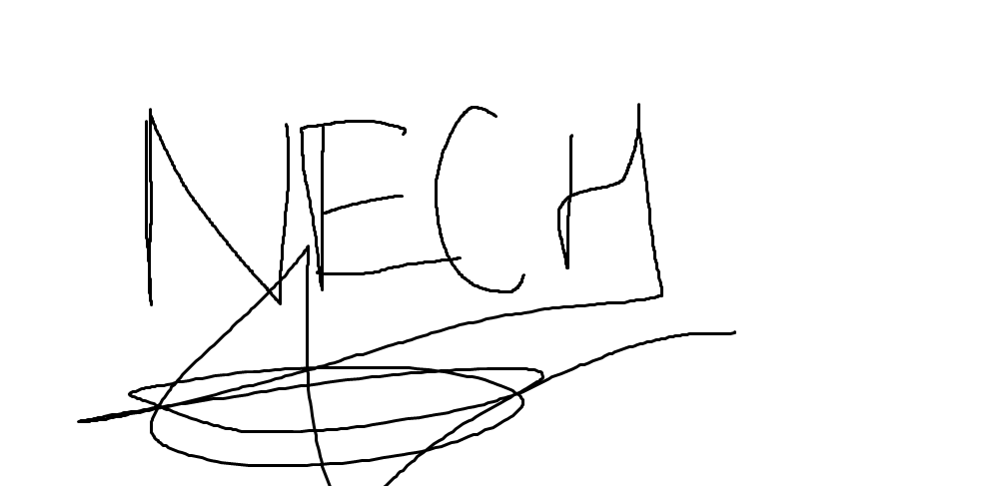

The part of the code that was more challenging for me was the following:

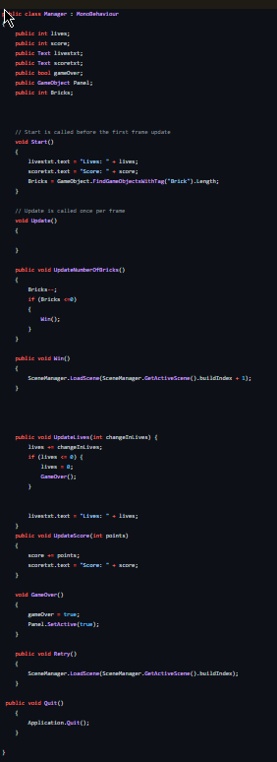

I found it this the more challenging because the code in this script was the one that involves all the connection with the other scripts for the game. So I had to add everything involving the lives, score, winning, etc.

In the first paragraph of the code, I state that you start with 3 lives in every level and when the ball touches the brick the player will get a point when the brick breaks.

In the following paragraph, the function of the code is that if the number of bricks is lower than 0, the player wins the level or the game.

The other paragraph is written so that if the player lives are lower or equal than 0 the player will lose and the game over screen will appear.

When the player hits a block the player will earn a point and it will add up to the score